14u Central Cal Dirt Dogs - Harger
Powered By Team Mizuno
 | #1  Genesis Zamora  Third Base / First Base  Class of 2016  559.994.7398  mizamora@verizon.net |  | #2  Halle Harger  Second Base  Class of 2017  559.970.6966  jharger223@aol.com | 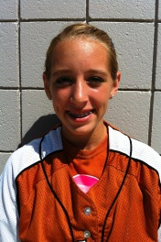 |  | #3  Savanah White  Pitcher / First Base  Class of 2016  559.972.5094  Christi.White@cigna.com
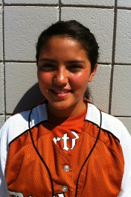 | #8  Angelina Meza  Shortstop / Second Base  Class of 2016  661.342.1325  meza.monique@yahoo.com | 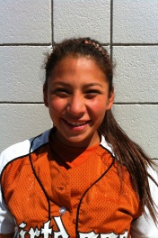 | #9  Samantha Mejia | 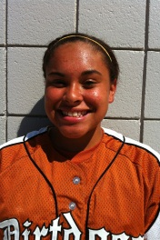 |  | #10  Arianna Gooden
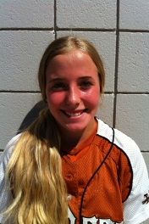 | #11  Spencer Sansom  Pitcher / OF / First Base  Class of 2016  559.908.7850  brandysansom@cusd.com | 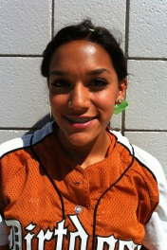 | #12  Ciera Montalvo  Pitcher / First Base  Class of 2016  559.960.1229  kimberly-montalvo@sbcglobal.net |  |  | #13  Elizabeth Torosian  Catcher/ Corners  Class of 2016  559.300.3017  lizzyt13@yahoo.com
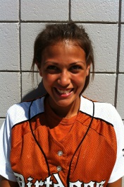 | #15  Keeley Hernandez  Outfield  Class of 2016  559.359.8267  mhras@sbcglobal.net | 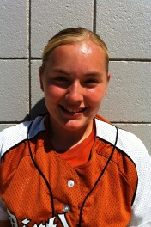 | #16  Maricelo Ramirez  Second Base  Class of 2016  661.809.5378  fromero47@yahoo.com | 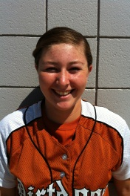 |  | #17  Kelcey Carrasco  Catcher / Third Base  Class of 2016  559.694.1306  softballchica17all@sbcglobal.net
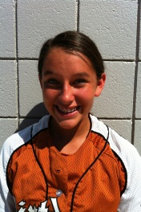 | #22  Cassidy Clark  Shortstop/Second/OF  Class of 2016  559.323.0725  kpclark22@aol.com | 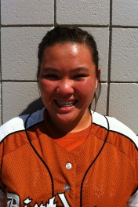 | #24  Starr Vang  Catcher / First Base  Class of 2016  559.824.6852  superstarrvang@gmail.com | 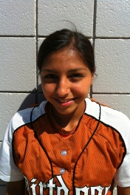 |  | #29  Lilianna Perez  Outfield / Infield  Class of 2016  559.875.4824  Lilianna_Perez@comcast.net

14u Central Cal Dirt Dogs – Harger – Powered By Team Mizuno
Dirt Dog is an athletic nickname given to certain players who are scrappy, blue-collar, hardworking and tenacious.
# | Last | First | Year | Pos | Ht | B/T | GPA | SAT | Email |  | Address | Phone
1 | Zamora | Genesis | 2016 | 3B/1B | 5’7” | R/R | 4.0 |  | mizamora@verizon.net |  | 1837 Geary Ave.  Sanger, CA 93657 | 559.994.7398
2 | Harger | Halle | 2017 | 2B | 5’ 3” | R/R | 3.75 |  | jharger223@aol.com |  | 14095 Fargo Ave.  Hanford, CA 93230 | 559.730.6966
3 | White | Savanah | 2016 | P / 1B | 5’ 5” | R/R | 3.67 |  | christi.white@cigna.com |  | 5003 W. Modoc Ave  Visalia, CA 93291 | 559.972.5094
8 | Meza | Angelina | 2016 | SS/2b | 5’ 5” | R/R | 3.0 |  | meza.monique@yahoo.com |  | 8118 Willoughby Ct.  Bakersfield, CA 93313 | 661.342.1325
9 | Mejia | Samantha | 2016
10 | Gooden | Arianna | 2016
11 | Sansom | Spencer | 2016 | P  OF/1B | 5’5” | L/R  Slap | 4.0 |  | brandysansom@cusd.com |  | 7790 N. Barton Ave  Fresno, CA 93720 | 559.908.7850
12 | Montalvo | Ciera | 2016 | P / OF | 5’ 2” | R/R | 3.5 |  | kimberly-montalvo@sbcglobal.net |  | 4172 N. Ceclia Ave  Fresno, CA 93722 | 559.960.1229
13 | Torosian | Elizabeth | 2016 | C  1B/3B | 5’ 4” | R/R | 3.67 |  | lizzyt13@yahoo.com |  | 2334 South Beech Dr.  Visalia, CA 93292 | 559.300.3017
15 | Hernandez | Keeley | 2016 | OF | 5’ 5” | R/R | 3.6 |  | mhrams@sbcglobal.net |  | 2245 E. La Vida Ave  Visalia, CA 93292 | 559.359.8267
16 | Ramirez | Maricela | 2016 | 2b | 5’ 1” | R/R | 3.2 |  | fromero47@yahoo.com |  | 156 N. Stine Road  Bakersfield, CA 93309 | 661.809.5378
17 | Carrasco | Kelcey | 2016 | C / 3B | 5’ 9” | R/R | 3.75 |  | softballchica17all@sbcglobal.net |  | 33680 Road 204  Woodlake, CA 93286 | 559.694.1306
22 | Clark | Cassidy | 2016 | SS  2b/Of | 5’ 2” | r/r | 4.0 |  | kpclark22@aol.l.com |  | 8115 N. Rowell  Fresno, CA 93720 | 559.323.0725
24 | Vang | Starr | 2016 | C / 1B | 5’ 6” | R/R | 4.0 |  | superstarrvang@gmail.com |  | 175 Loyola Avenue  Clovis, CA 93619 | 559.824.6852
29 | Perez | Lilianna | 2016 | OF/IF | 5’ 1” | L/R  Slap | 4.0 |  | lilianna_perez@comcast.net |  | 750 12th Street  Sanger, CA 93657 | 559.875.4824
Coach: Jeff Harger  559.730.6966  jharger223@aol.com |  |  |  |  |  |  |  |  |  | www.centralcaldirtdogs.org

